**Login Page and Onboarding Process – Sign Up New User – Welcome Page**

Datamond Kevin - 0250303

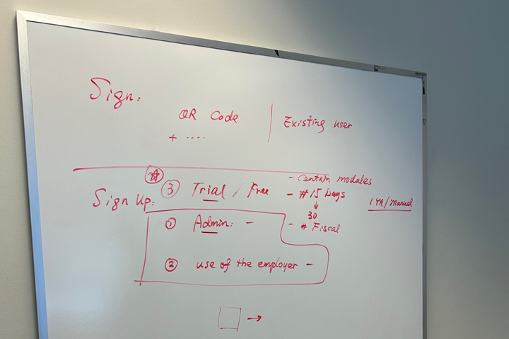

**WELCOME PAGE**

**Title: Welcome to XaiBooks**

**1️. Greeting Message:**

* Thank you for joining XaiBooks! Before we set up your business profile, please let us know if your company is incorporated Federally or Provincially. This helps us tailor your registration process.
  + Federal
  + Provincial (Select Your Province/Territory) (Dropdown)
* Not sure which option to choose? [Learn more about the difference between Federal and Provincial Incorporation.] (Link)

**2. Navigation Footer:**

* Already started your setup? [Resume Registration] (Button)
* Need help? Contact our support team.